SQL ASSIGNMENT 1

create table Product(

ProductID int not null primary key,

ProductName varchar(50) not null,

SupplierID int not null,

CategoryID int not null,

QuantityPerUnit varchar(50),

UnitPrice decimal(10,3) not null,

UnitsInStock int not null,

UnitsOnOrder int not null,

ReorderLevel int not null,

Discontinued bit

)

insert into Product

values(4,'Chef Anton Cajun Seasoning ',2,2,'48 - 6 oz jars ',22.000,53,0,0,'false'),

(5,'Chef Anton Cajun Seasoning ',2,2,'36 boxes ',21.500,0,0,0,'true'),

(6,'Chef Anton Cajun Seasoning ',3,2,'12 - 8 oz jars ',25.000,123,0,25,'false'),

(7,'Chef Anton Cajun Seasoning ',3,7,'12 - 1 lb pkgs. ',30.000,15,0,10,'false'),

(8,'Chef Anton Cajun Seasoning ',3,2,'12 - 12 oz jars ',40.000,6,0,0,'true'),

(9,'Chef Anton Cajun Seasoning ',4,6,'18 - 500 g pkgs. ',97.000,29,0,15,'false'),

(10,'Chef Anton Cajun Seasoning ',4,8,'12 - 200 ml jars ',31.000,31,0,10,'false'),

(11,'Chef Anton Cajun Seasoning ',5,4,'1 kg pkg. ',21.000,22,30,30,'false'),

(12,'Chef Anton Cajun Seasoning ',6,8,'10 - 500 g pkgs ',38.000,86,0,0,'false');

select \* from Product

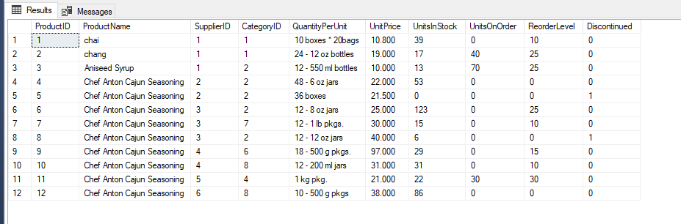

1. Write a query to get a Product list (id, name, unit price) where current products cost

less than $20.

select ProductId,ProductName,UnitPrice from Product where UnitPrice <20;

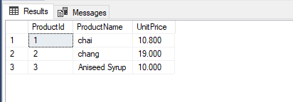

2. Write a query to get Product list (id, name, unit price) where products cost between

$15 and $25

select ProductId,ProductName,UnitPrice from Product where UnitPrice between 15 and 25;

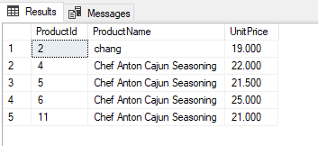

3. Write a query to get Product list (name, unit price) of above average price.

select ProductName,UnitPrice from Product where UnitPrice >(select avg(Unitprice) from Product);

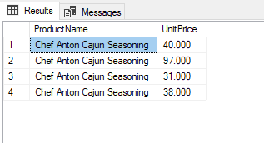

4. Write a query to get Product list (name, unit price) of ten most expensive products

select top 10 ProductName,UnitPrice from Product order by UnitPrice desc;

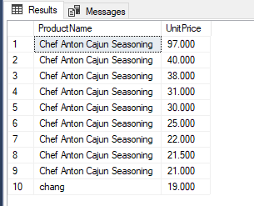

5. Write a query to count current and discontinued products

SELECT Discontinued ,Count(Discontinued) FROM Product GROUP BY Discontinued;

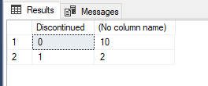

6. Write a query to get Product list (name, units on order , units in stock) of stock is less than the quantity on order

select ProductName,UnitsOnOrder,UnitsInStock from Product where UnitsInStock<UnitsOnOrder;

